**Web Development**

**Project Report**

Problem Description

The website I have created is based on tourism in Ireland. The aim was to create a minimal, easy to use website, so that is handy for all types of users. This website contains information about tourist destinations and events in Ireland, making it easier for tourists to search and plan their holiday accordingly. Each webpage contains a nav bar at the top that makes it easier for the user to navigate to other pages. Each web page contains a footer at the bottom. The footer also contains navigation links to all the pages, so the user doesn’t have to scroll back up to visit another page. It also contains navigation links to all the tourist social media pages and a contacts details of the tourists off.

The website contains of five pages home, gallery, contact, events and discover page. Home page is designed in a way to make it easy for the user to navigate through all the pages. It also has video on display to introduce the user to Irish landscape and make them feel homely. The galley page has pictures on display of the tourist destinations, so that they can discover for themselves about the place they are planning to visit. The contacts page is divided into two sections. This first section has contact details for tourist offices on display and the second section has a review form, so users can provide useful feedback. The events page contains all the information about major events held in Ireland. On display are the names of the events, location, date, event image and a shot description of the event. Lastly the discover section contains all the names for major tourist destinations in Ireland, an image associated with each destination name and a short description of that place.

Research

As a part of my research I analysed three tourist websites that were already available. These websites were [www.tourismireland.com](http://www.tourismireland.com), [www.discoverireland.ie](http://www.discoverireland.ie), and [www.failteireland.ie](http://www.failteireland.ie). While analysing these websites I gathered pros and cons about each website.

Tourism Ireland was a well-built website containing easy navigation to each web page. It also contained large amount of useful data for the users. This website contained a lot of features like responsive CSS styling, image slide show, nav bars, videos and good use of java script. However, there were some flaws as well. There was no easy way to discover tourist destinations in Ireland, the website was more about what the company does and not about Irish tourism and too much information was presented.

Discover Ireland had a minimal website and was easy to use. It contains a nav bar, footer, well displayed information for tourists and good use of web development techniques like use of cards and tabular structure. This website is very informational for users as it provides information about tourist destinations. The search box made it easier to search places. There were some minor flaws in this website like the nav bar had too much content in it making it hard for some people to use, and there was no information about tourist offices.

Failte Ireland is a basic website providing information about tourism. This website was the least appealing and looked out of date. The website had lot of small containers with al lot of data, making it unappealing. This offers a constant layout through all the webpages, which means reusable CSS was used. The website lacked modern design with a lot of square boxes and not curved edges, and with similar font throughout all web pages. The site was also hard to navigate with too many links present and with a very basic nav bar.

Carrying out the research helped me find out important aspects for my website. I decided to make a website that had modern design and was easy to use. I decided to include a nav bar, a photo gallery as none of the websites above had one, include a contacts page, display information about tourist destinations and events in Ireland. The websites should only contain information that is useful to costumers.

Technology Selection and Site Architecture

For this website I decided to used HTML 5 as it was the latest version of html present and offered the latest features. HTML 5 also provides consistency through multiple browsers, websites are semantically accurate therefore a rank in search engines, provides better user experience by offering wider range of design and presentation tools across media types and lastly provides offline browsing when the code for the website is stored locally in the form of offline application cache. For styling id used CSS 3 as it was the latest version and had many advantages. CSS 3 has many advantages including cross browser compatibility, compatibility with older versions of CSS, providing new styling features, better styling for container and positioning of containers, and good compatibility with HTML 5.

To develop my website, I decided to use containers and divide content using multiple containers. The header contained the title of the tab. I decided to include a footer section in each page. The body section contained all the data of the main page. Included in each of the pages would be nav bar and all the content would be placed between the nav bar and the footer. Most basic feature for modern websites is to responsive and the content should adjust itself according to the browser width. To implement this, I used relative metrics in CSS, so that the content would change according to the width and height of the browser. I also used responsive design in CSS to make a drop down nav bar if the width dropped below certain pixels.

The website is mainly created for computer users but can also be accessed from mobile phones and tablets. If used from a mobile phone some of the features might not work as designed to be but all the features will available and all the content will be displayed correctly according to browser with. The website was built on chrome and has also been tested on internet explorer and works perfectly on both browsers. There will be no compatibility issues in other browsers as well.

Low Fidelity Prototype

Home page (index.html) wireframe:

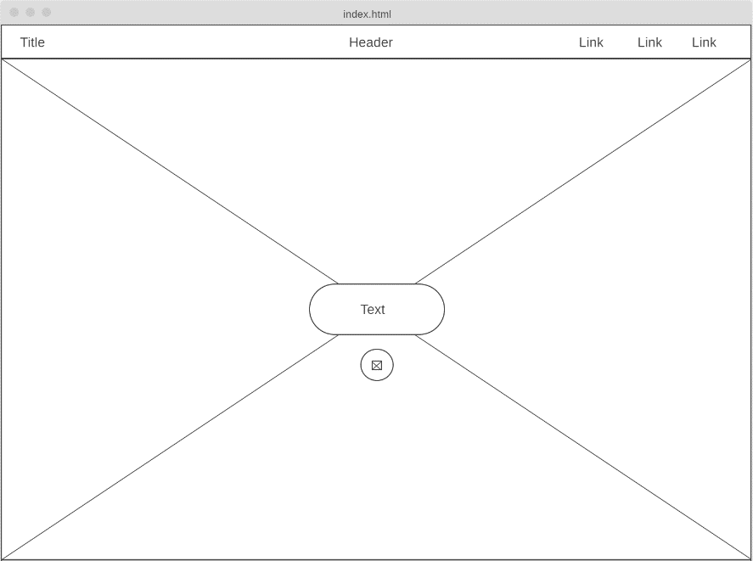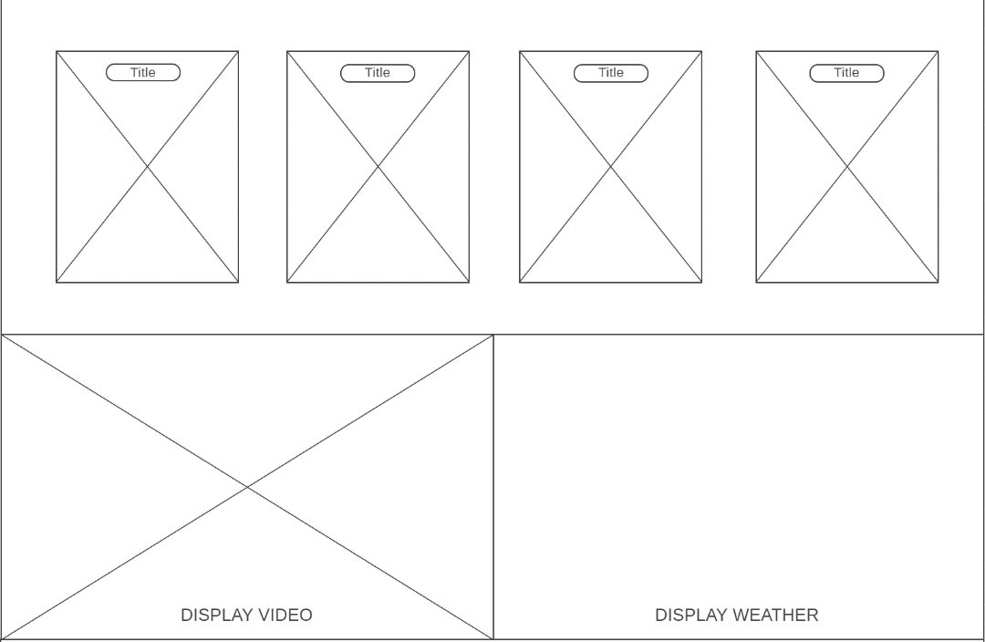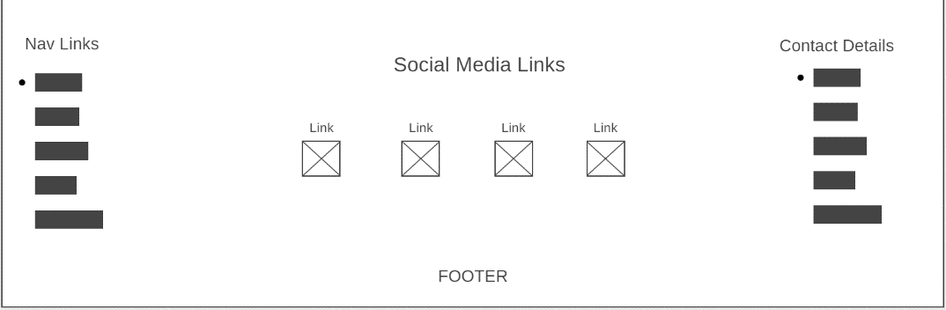

The home page was designed in a way to make it easy for the user to navigate to different parts of the website. The big image at the start introduces the user to Irish landscape. The large image buttons are easy to find and are eye-catching. The video box at the bottom will give the user more information. Nav bar is found at the top with easy to navigate links. All the pages follow a modern and minimal structure with no side menu. This also makes the site easy to navigate and less confusing.

Contact page (contact.html) wireframe:

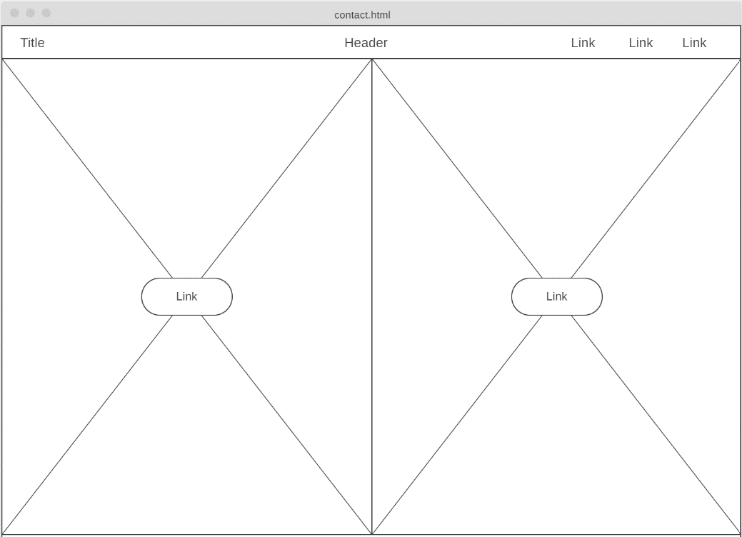 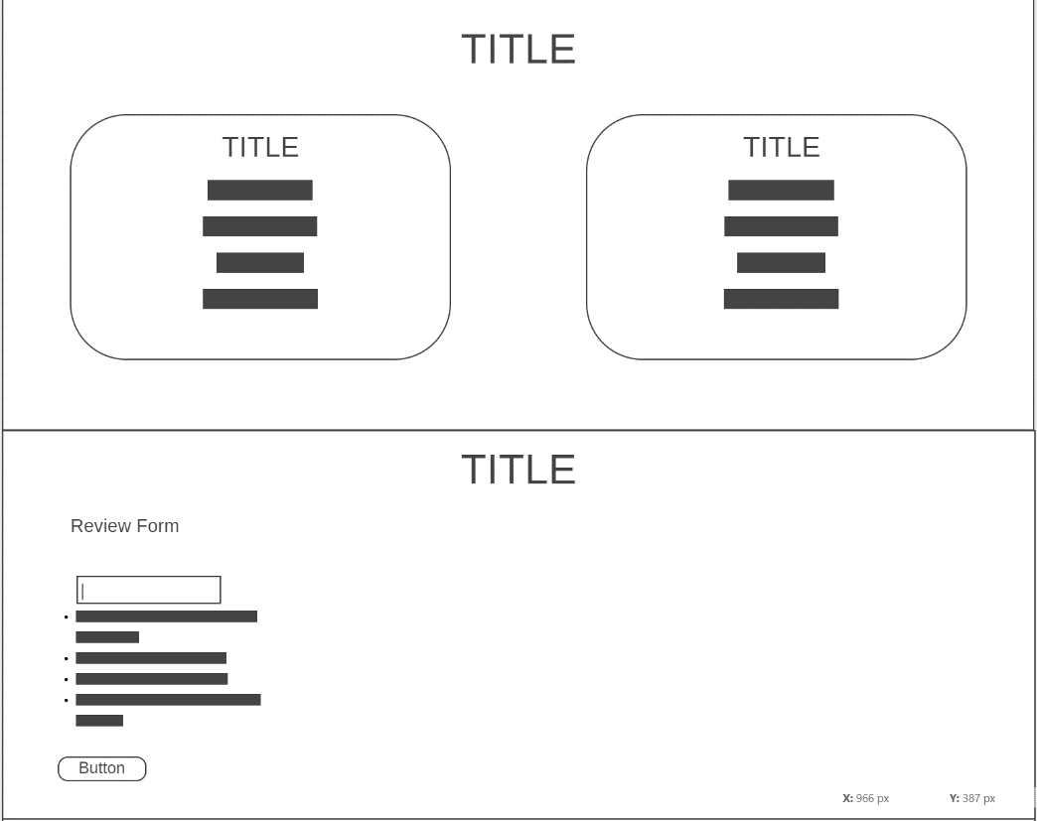 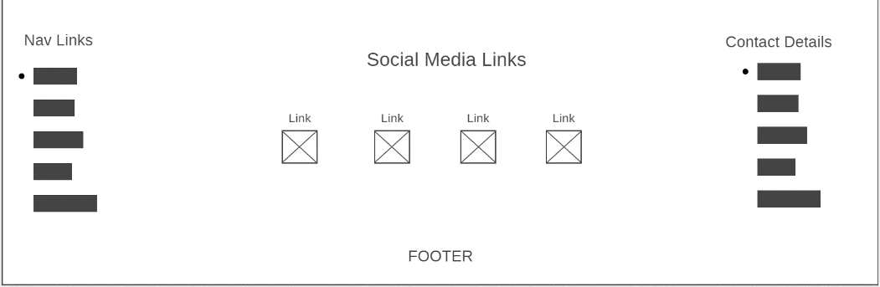

The contacts page carries the same footer and nav bar from home page. The are lot of curved containers to give the site a modern design. Each part is divided into different sections. The two images at the top of page introduces the user gently to this page and all the other information is found on the other half of the page. Footer was included to contain all the necessary links, so the user does not have to scroll all the way back up.

Discover page (discover.html) wireframe:

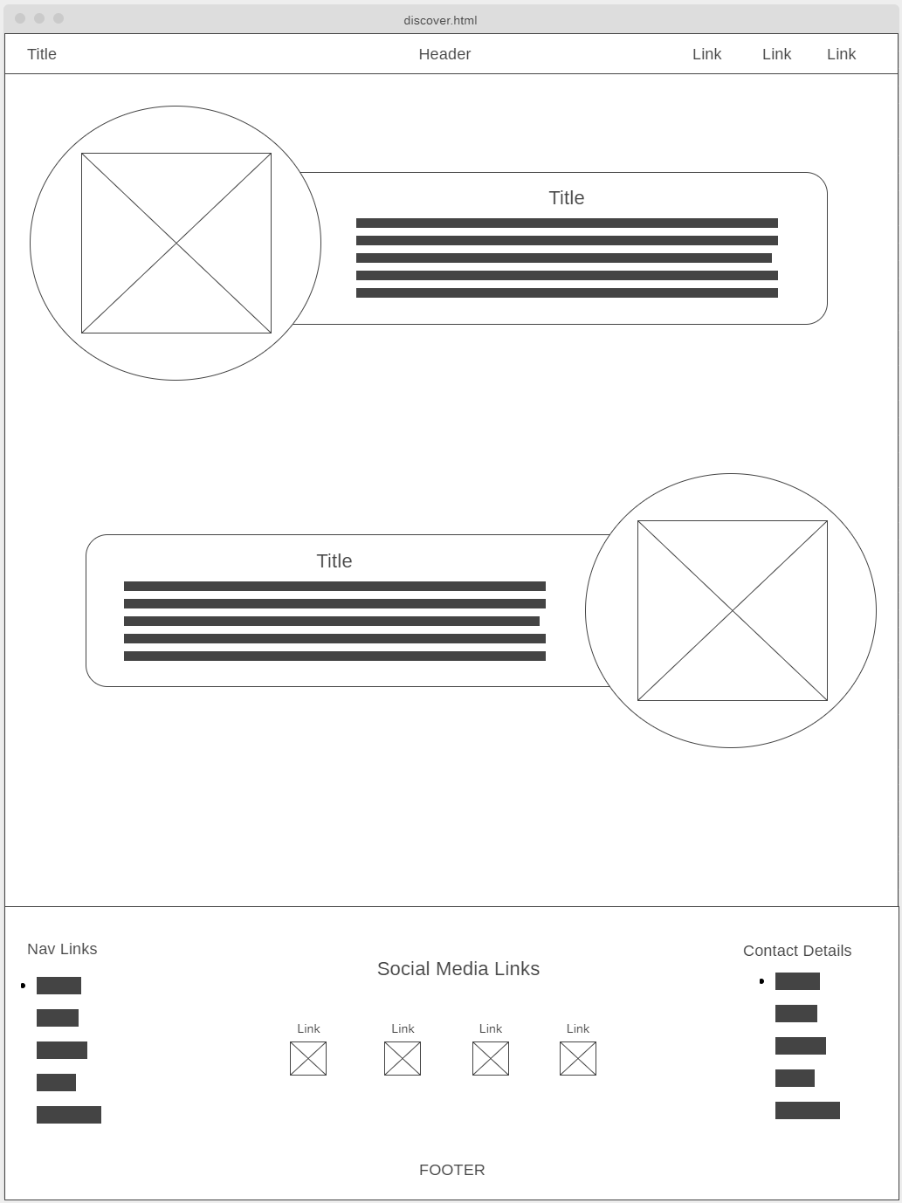

Curved containers were used to give a modern look to this page. Each article is given its own box to create a focus on a topic. This also makes it easier for the user to locate all the information regarding one topic at a same place. Curved edges are subtle to the eyes. The images provide a short view of each destination. This attracts the user to the type of places they like the most.

Events page (event.html) wireframe:

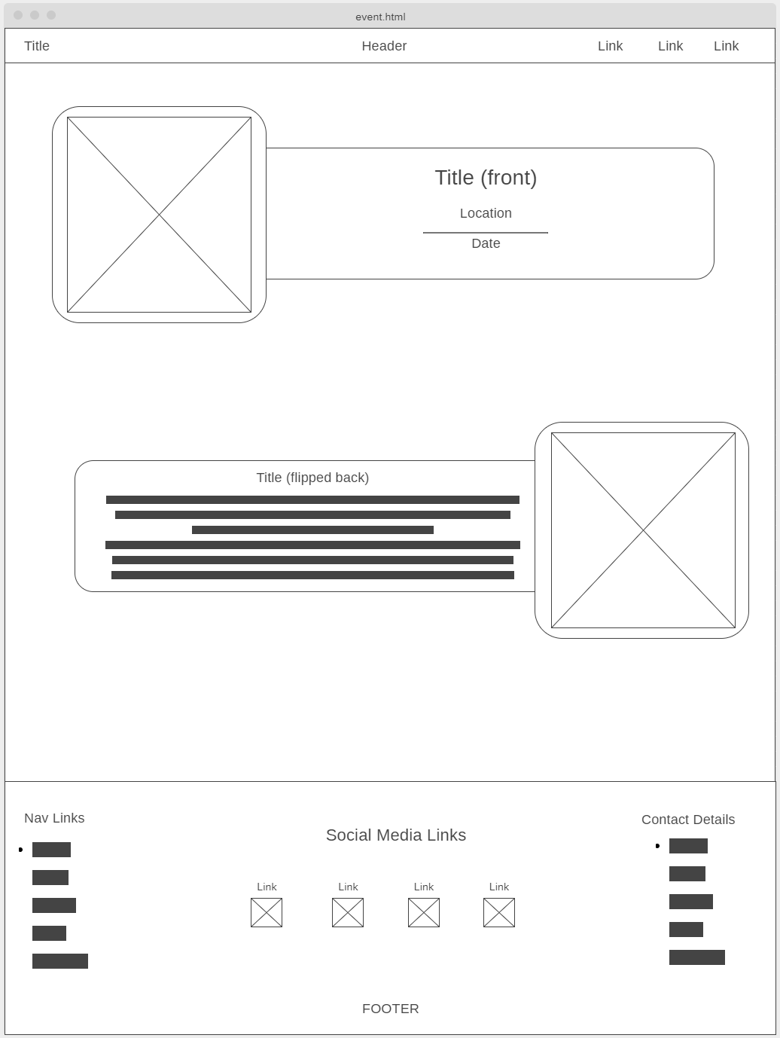

Following the modern theme curved boxes were used again. This site also uses a flip container to make the site more interactive. This site is similar to the discover site, so that user get familiar to design and this will make it easier for them to find data. The big titles upfront are easy to find and are eye catching. The image with each container attracts attention of users to events the like the most. The images are also informative.

Gallery page (gallery.html) wireframe:

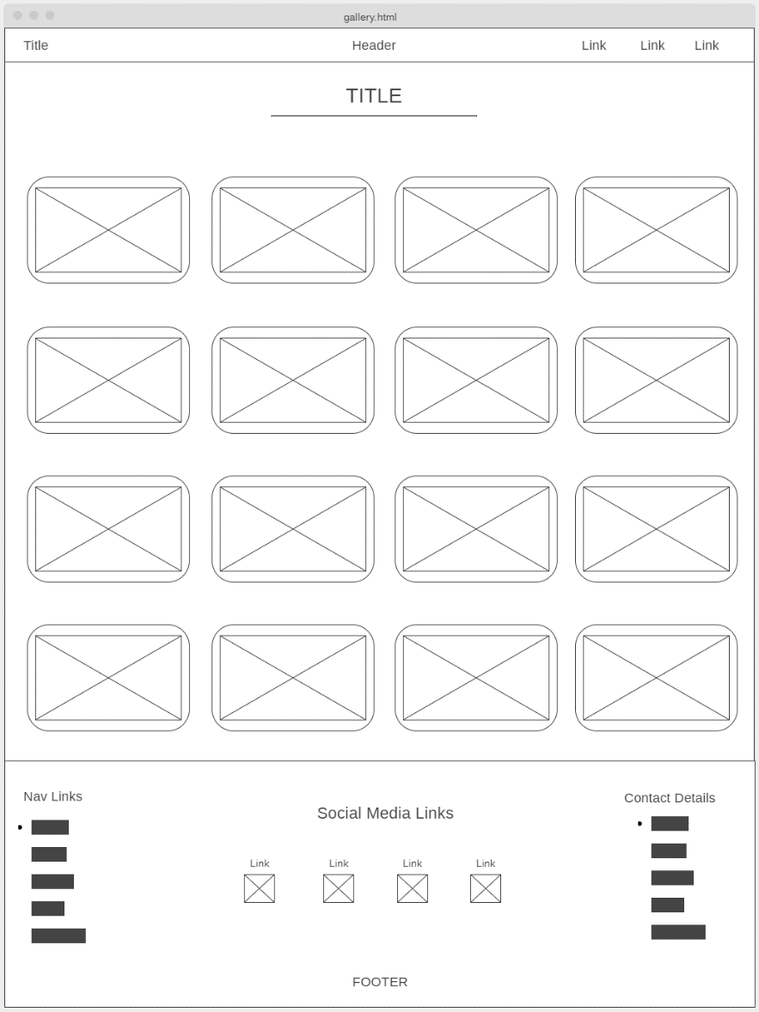

This page was designed in way that I would provide an overview of Ireland. The small images stacked together in a table format provide the user grid view of the images. This presents users information upfront. The title up top introduces the user gently to the page.

Development Plan

The very first thing to keep in mind is planning the website. I will first decide on a topic to develop my website on. After a topic has been chosen, I will then decide on the topics of the 5 web pages. After a topic has been decided for each webpage, data under each topic will gathered and stored. After all the data that needs to be shown on the website has been collected, designing process will start. Wireframes will be created for each webpage and the webpages will be created accordingly. Wireframes will contain visual structure of each web page, which will make it easy to implement while coding.

The website contains 5 pages and each page will be created one by one. Basic html structure of each site will be created. Then reusable content like the footer and nav bar will be created. The html, CSS and JavaScript code will be kept separately as external files and will not be implemented in the html. Each project requirement will be noted, and the sites will be created accordingly. To design the sites first the content data will be fill in the html, CSS will then be used to style this data according to the wireframes and java will then be used to make the webpages interactive if necessary. While coding the code will be tested using chrome browser, and to check the output of the code. Once one webpage is finished, work on the next webpage will start and same content code will be copied. As CSS and JavaScript coding is done in an external file, the styling will automatically be applied after linking to the external CSS file.

Once each website is done testing will begin. Website will be tested different browsers. HTML and CSS validation will be done to ensure there are no errors. Developer tools in chrome and internet explorer will be used to check for errors as well. Once satisfied with the website it will deployed and published on the internet.

While creating the website it was made sure that CSS was used effectively. Styling for containers was reused while creating the footer and nav bar, the buttons on home page and contacts page, and the container in the events and discover pages. To make the code more efficient relative paths and CSS combinators were also used. This done by using same styling for multiple containers and storing external files in a way that the path to the files was easily accessible.

Testing Plan

While testing the website I use the chrome developer options to check the responsive design.

Responsive nav bar testing:

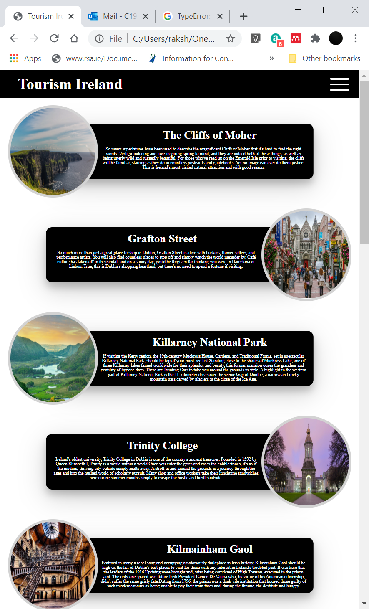

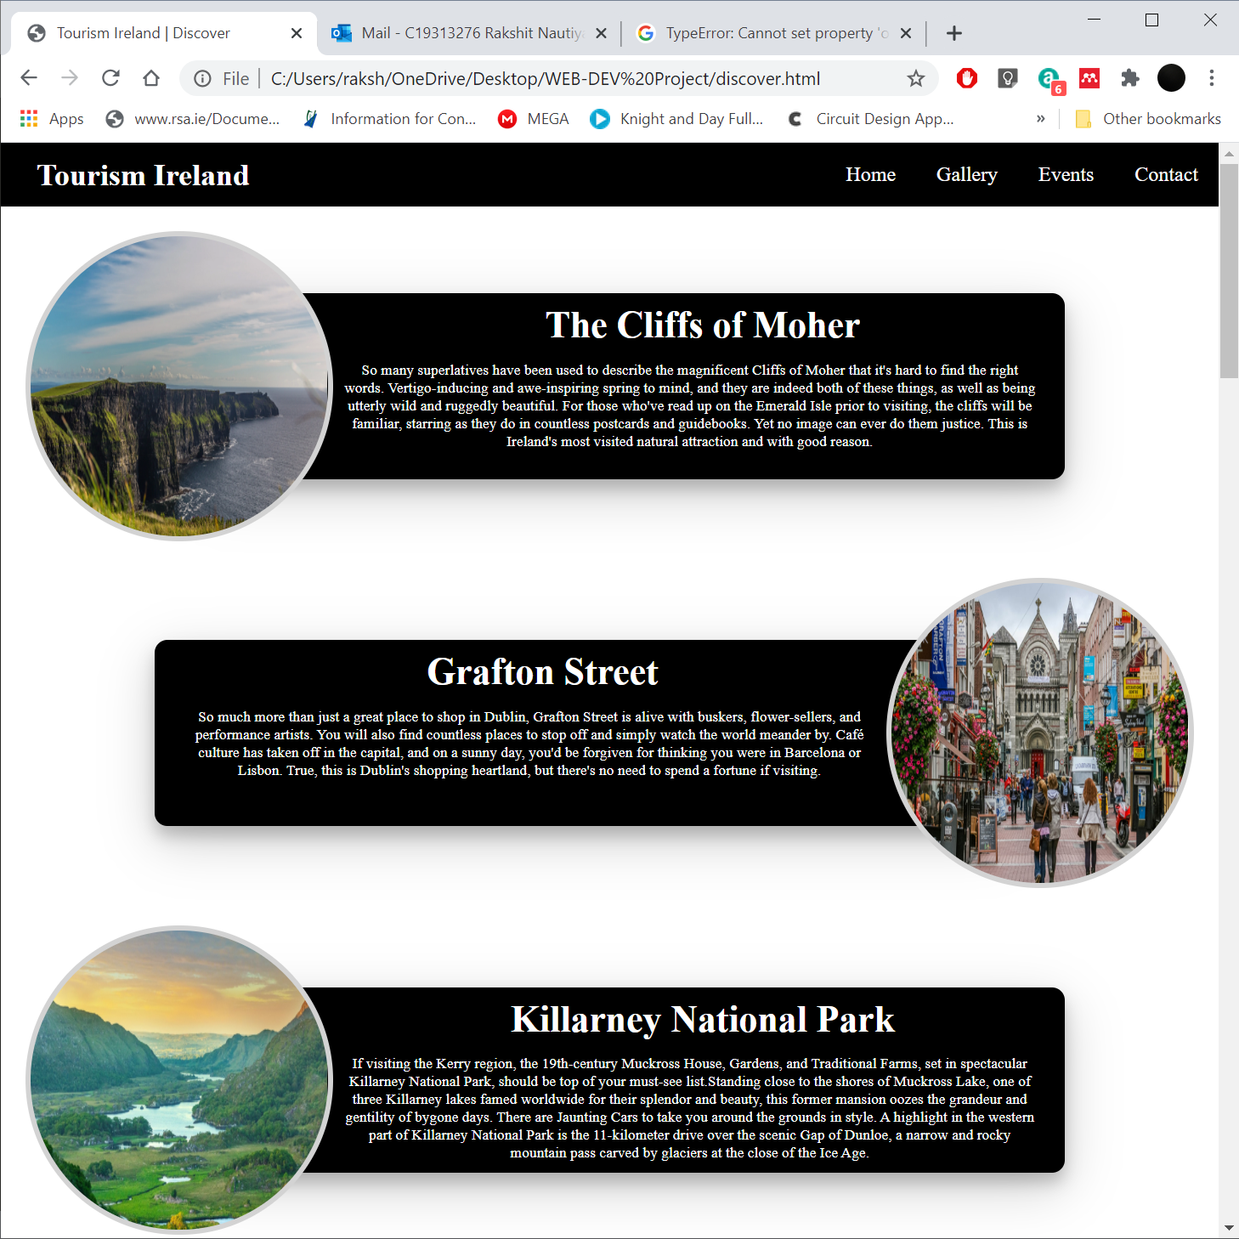

Testing responsiveness of the website

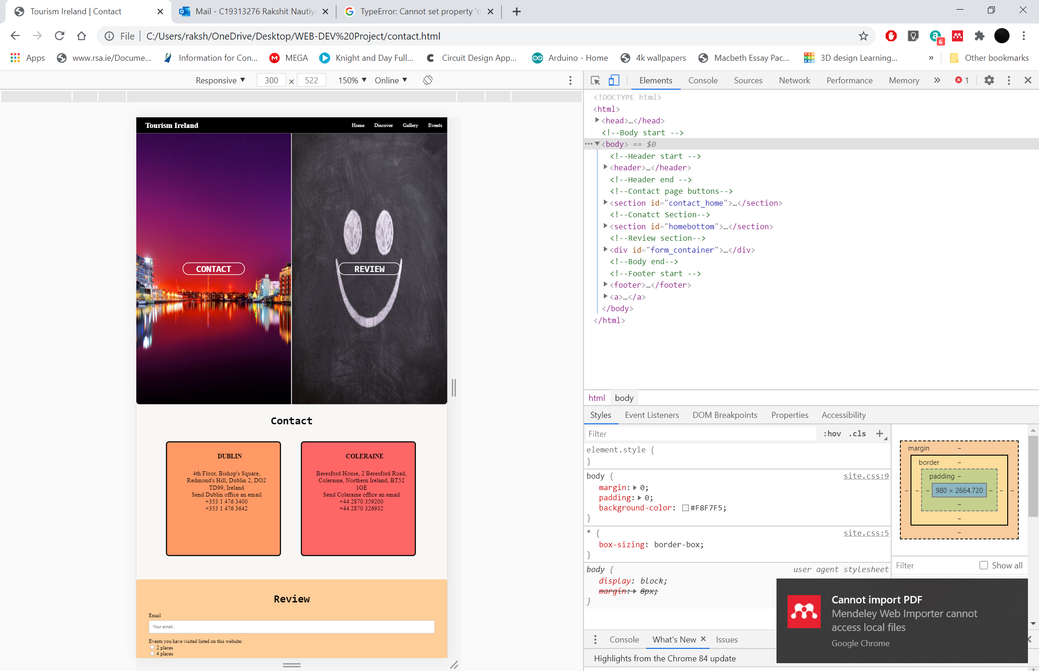

One error I could not remove was this console error.

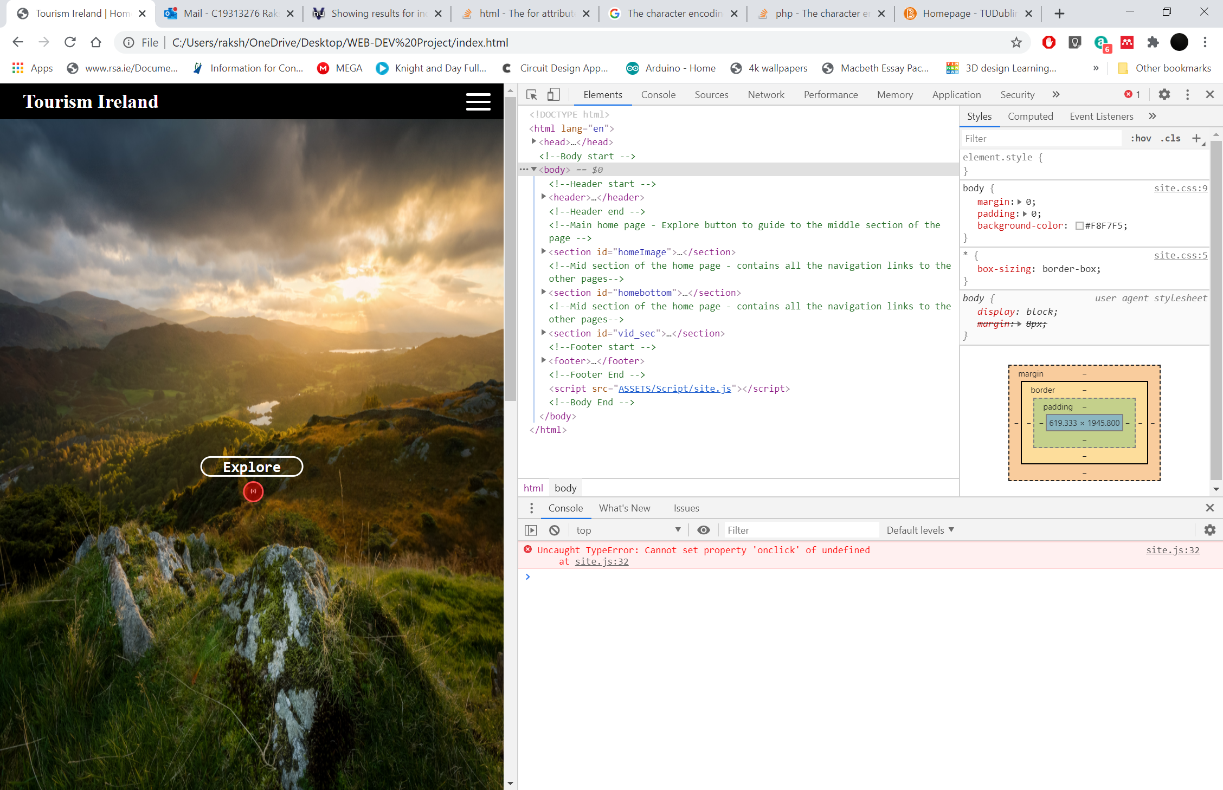

I have also used the w3s to remove errors from my web pages. All the pages showed no errors in the validation

Site Evaluation

I am quite satisfied with the website I have created. The website has a minimal design and easy to navigate. The website is also well structured with similar layout through all pages. It has a modern structure and contains all the aspects listed in the brief. It works well in all browsers and can also be accessed on phones and tablets. The website also fulfils the purpose of providing important information to customers like tourist destinations, photos, events and contact details of tourism offices. If I had a little bit more time in had hand, I would have included more animations and would have made the site more interactive using JavaScript and CSS.

Deployment

To deploy a website there are four steps. First create a website on a local machine. Get web hosting, which can be found on websites like cPanel. Include a meta tag in each web page that you have created. The meta tag contains information about the website created. This information is not displayed on the webpage but is used by search engines to learn about the content of the website. You then have to upload the site via FTP client. You will need an account with username and password which will be provided by the host services. After an account has been created, log in using FTP login details. After logging in copy all files and folders to the hosting via FTP. Originally hosting will be blank as this is a new website. Lastly add link to search engine like google.

To make your website appear at the top when searched search engine optimization needs to be done. To do the many things can be done. SEO audit can be done to improve search optimization. This is done by closely examining your overall site performance, setting new goals based on what you find, and implementing tactics to reach those goals. This process helps you increase your profits by making the best use of the content you already have. Another way is making your website compatible with more devices. Checking that your website has no errors can also help in search engine optimization. Using keywords that trend on search engines can also help. Tools like google optimize can also be used to analyse your website and check where implodents can be made.

Weekly Logs

Web Dev 1

Weekly Project Report – Week 9

Please provide a brief overview of the research or tasks that were completed on your project this week. (This should take no longer than 10 minutes to complete):

After carrying out some research I have finalised the topic I will make my website on. I had difficulties deciding the topic, after looking at many options eg. Site for a local business, site for my favourite football team, a blog, etc. Finally, I have decided to make a website on tourism in Ireland and tourist destinations in Ireland. I currently gathering data to put on my website.

Web Dev 1

Weekly Project Report – Week 11

Please provide a brief overview of the research or tasks that were completed on your project this week. (This should take no longer than 10 minutes to complete):

The wireframes are now completed. I am still working on the website. I have also stared the project report. I have encountered some problem with CSS styling but I have been doing research on how to get around this problem.

Web Dev 1

Weekly Project Report – Week 12

Please provide a brief overview of the research or tasks that were completed on your project this week. (This should take no longer than 10 minutes to complete

Completed 3 pages on my website. Working on project report. Some issues with the java script in the gallery page.

Web Dev 1

Weekly Project Report – Week 13

Please provide a brief overview of the research or tasks that were completed on your project this week. (This should take no longer than 10 minutes to complete):

Coming towards the end of my project. Completed all the websites. Adding form validation. Project report coming to end.

Web Dev 1

Weekly Project Report – Week 14

Please provide a brief overview of the research or tasks that were completed on your project this week. (This should take no longer than 10 minutes to complete):

The website has been completed and tested. All issues are fixed. The project report has also been completed. The website deployment has also been completed.